- Locate and click on Acronyms icon on Application Menu

- After clicking on Acronyms icon Animation Screen will appear and Initial Data will be loaded , you will see Screen as shown below
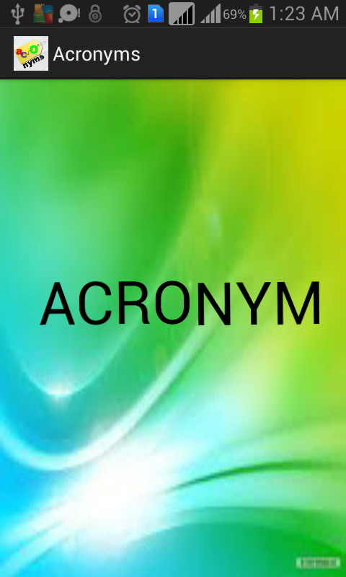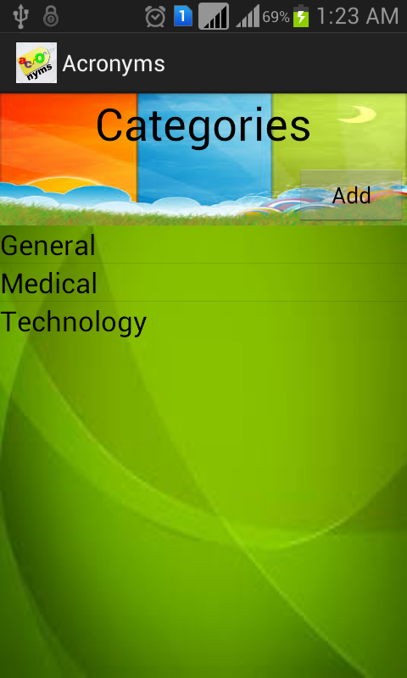
- On Clicking the Add button on top right corner of the screen you will get a Dialog box to insert new word or new category. On Entering Category name a category will be added (Sports in fig shown below)
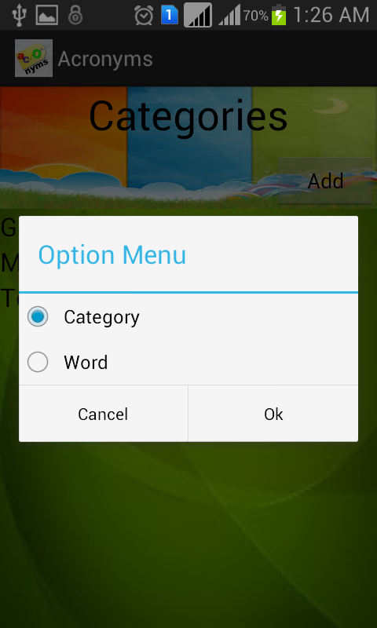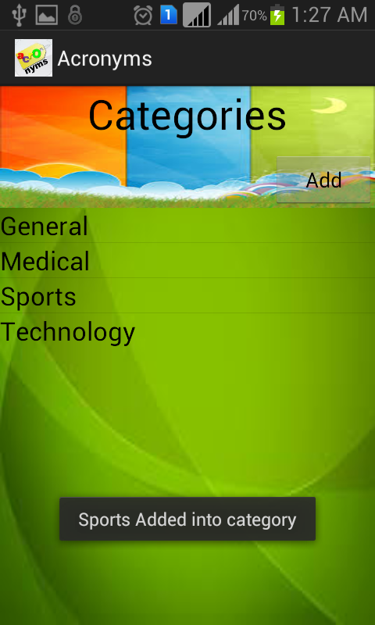
  - If Word is selected in the dialog box then a new dialog box appears asking for short form, full form and category of the word to be added.
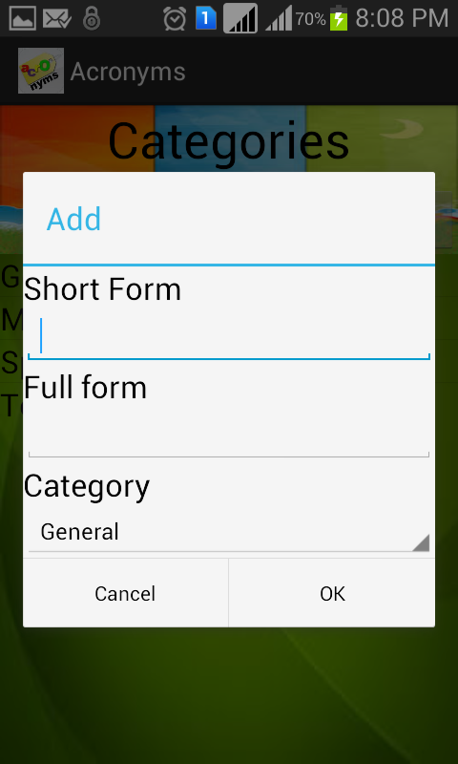
- On clicking on the any of the category you will get a list of all the words that belong to that category (All words of Medical Category are shown in fig). On Clicking on any word will give full form in a Toast
.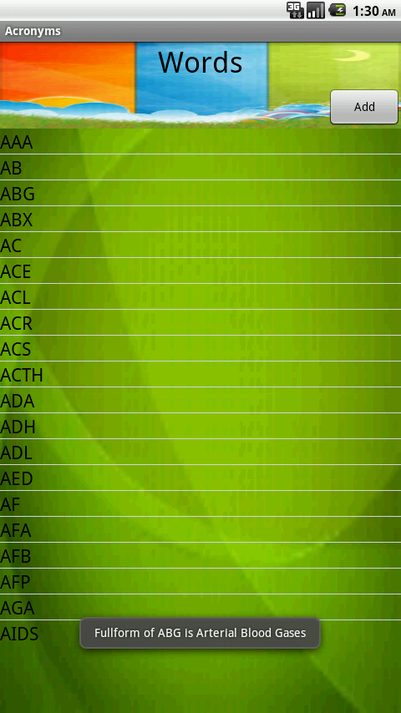
- On Clicking on Add Button on the right top corner a dialog box will appear in which short form and full form is to be given for the word that has to added into category (Medical Category in fig shown).

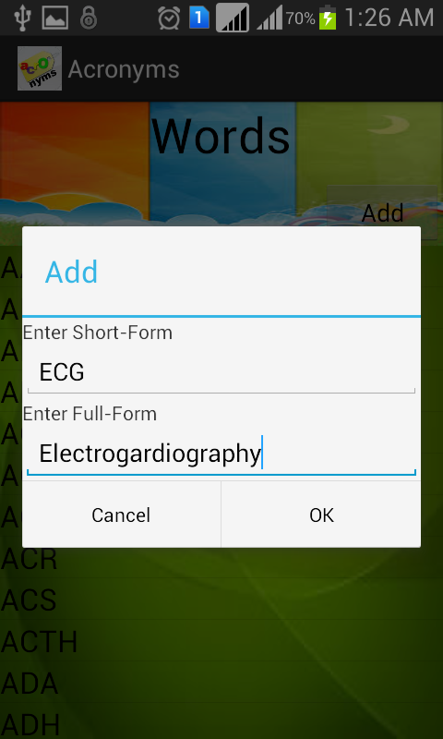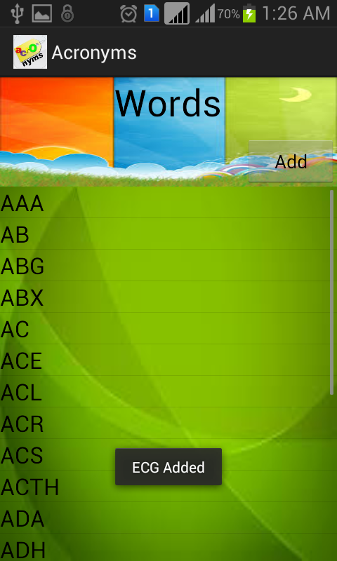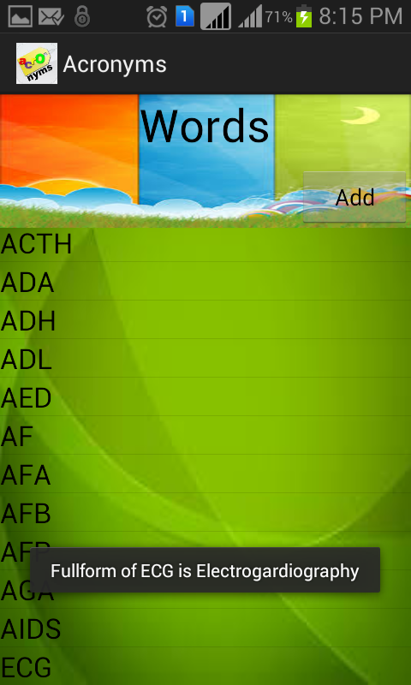

- On long click on any of the word will give you the option to edit or delete the word.
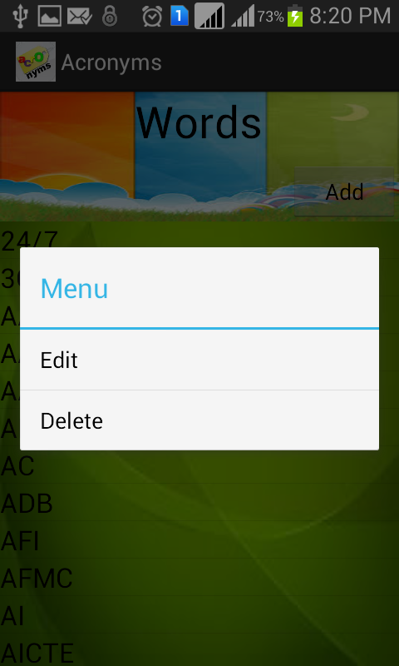
  - On clicking on edit option a new dialog box will appear asking for new full form of the word
(Here on long clicking on AAA gave a dialog with Edit and Delete as seen in above Screenshot above on selecting Edit Option the window shown in fig appears)

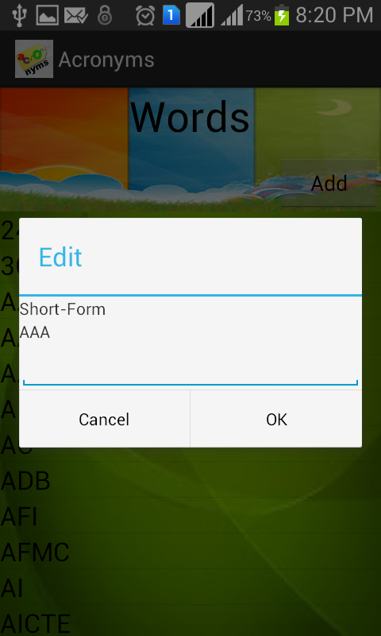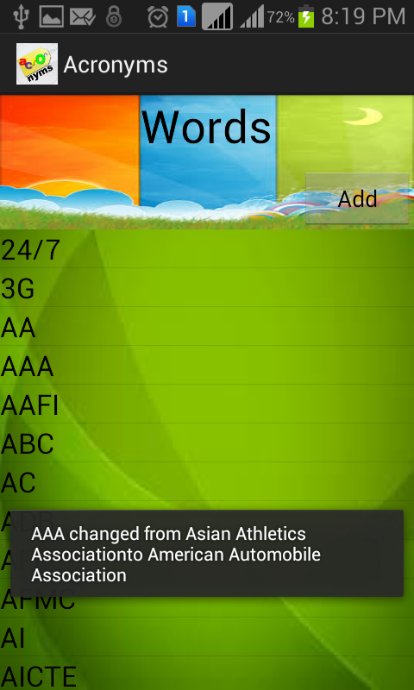

- On selecting delete option and confirming delete, Word will be deleted from the list(Here ECG is deleted )

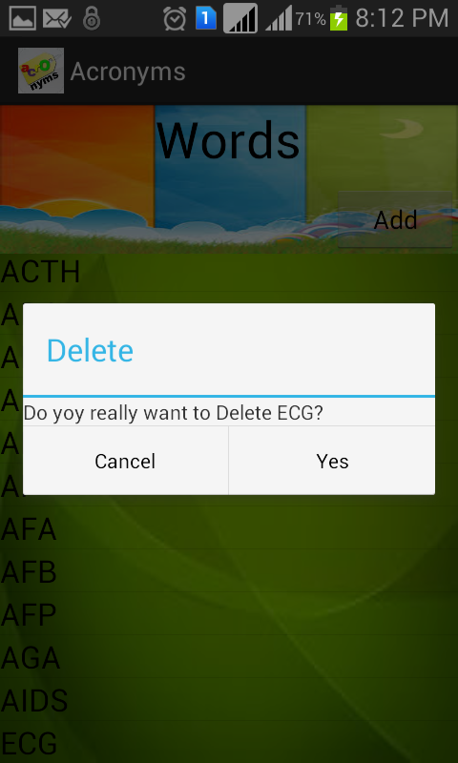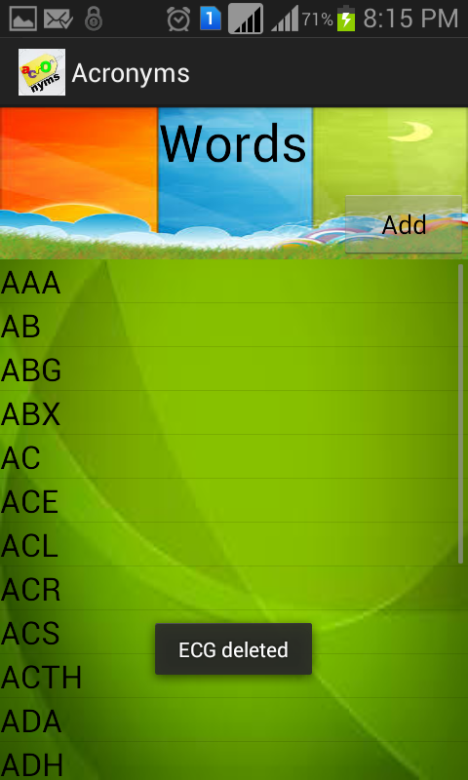

- On pressing back button you will be brought back to the Category menu. Long click on the list will give option to delete the entire list.(Sports category is deleted)

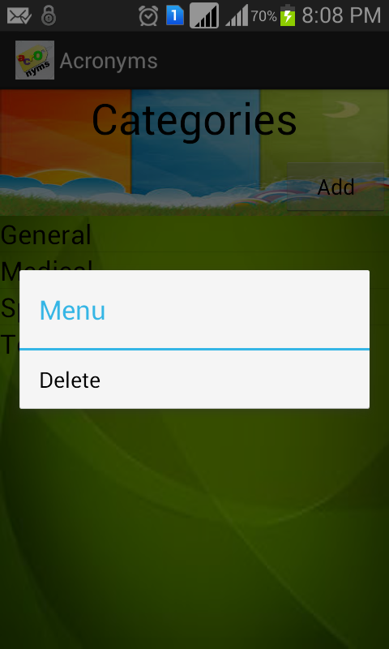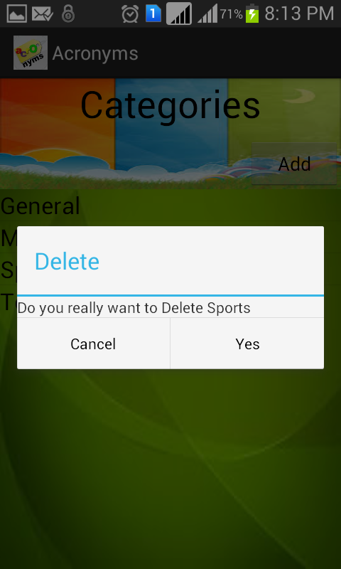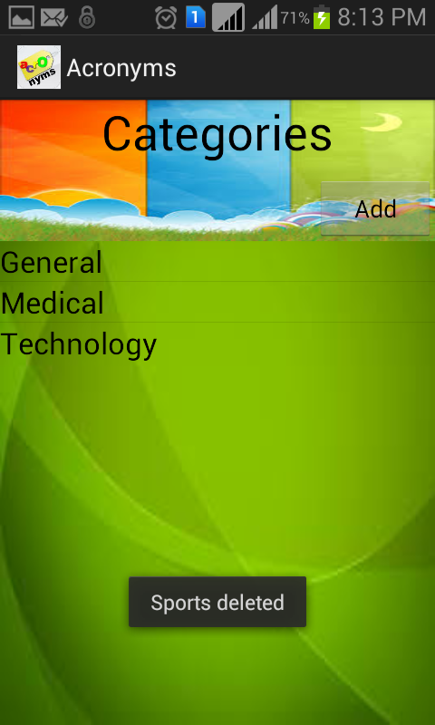

- On Pressing back button you will get a dialog confirming whether you really want to exit. On selecting Exit the app will exit and bring you to application menu

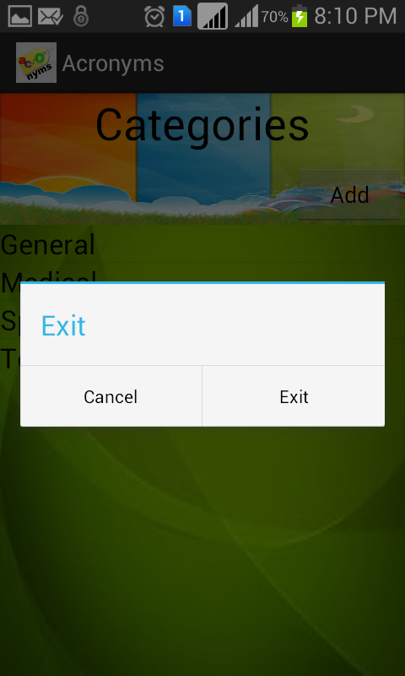

License
Distributed under GNU GPL Version 3

